Elephants Festival

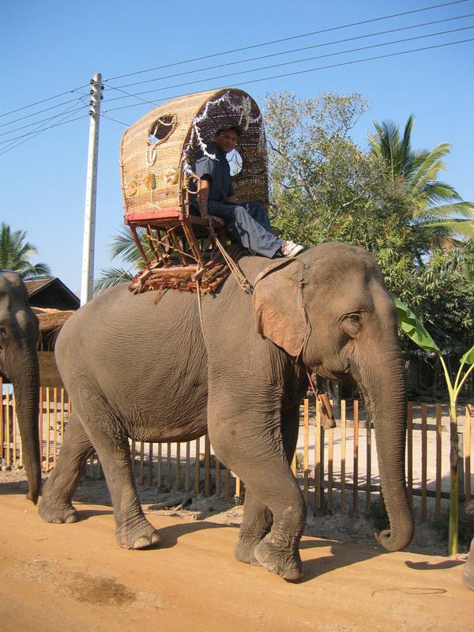

The elephants festival is a two-day celebration organized annually (mid-February) in Xayaboury province. Some 100 elephants and their mahouts from around the area gather to demonstrate working techniques and all things elephantine.

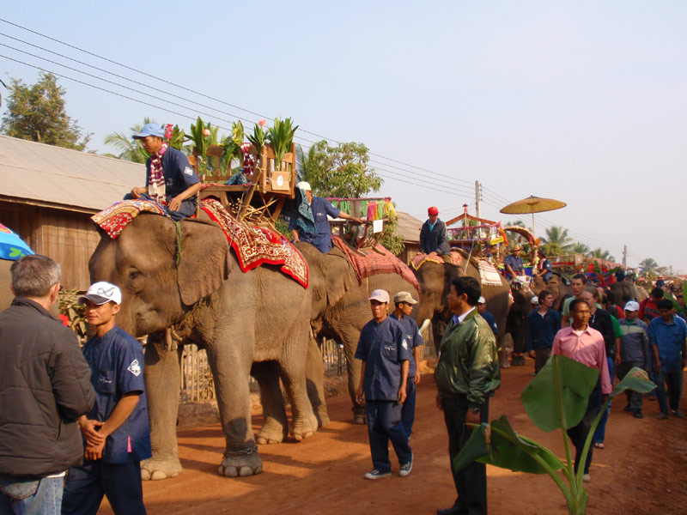

The celebration filled with elephant-related activities such as mahout and elephant shows, elephant procession, monks’ blessings, a traditional elephant Baci ceremony followed by the election of the Elephant of the Year. Visitors can enjoy documentary films on a an outdoor screen or live performances on the main stage. Elephant ride in the nearby forest is also available.

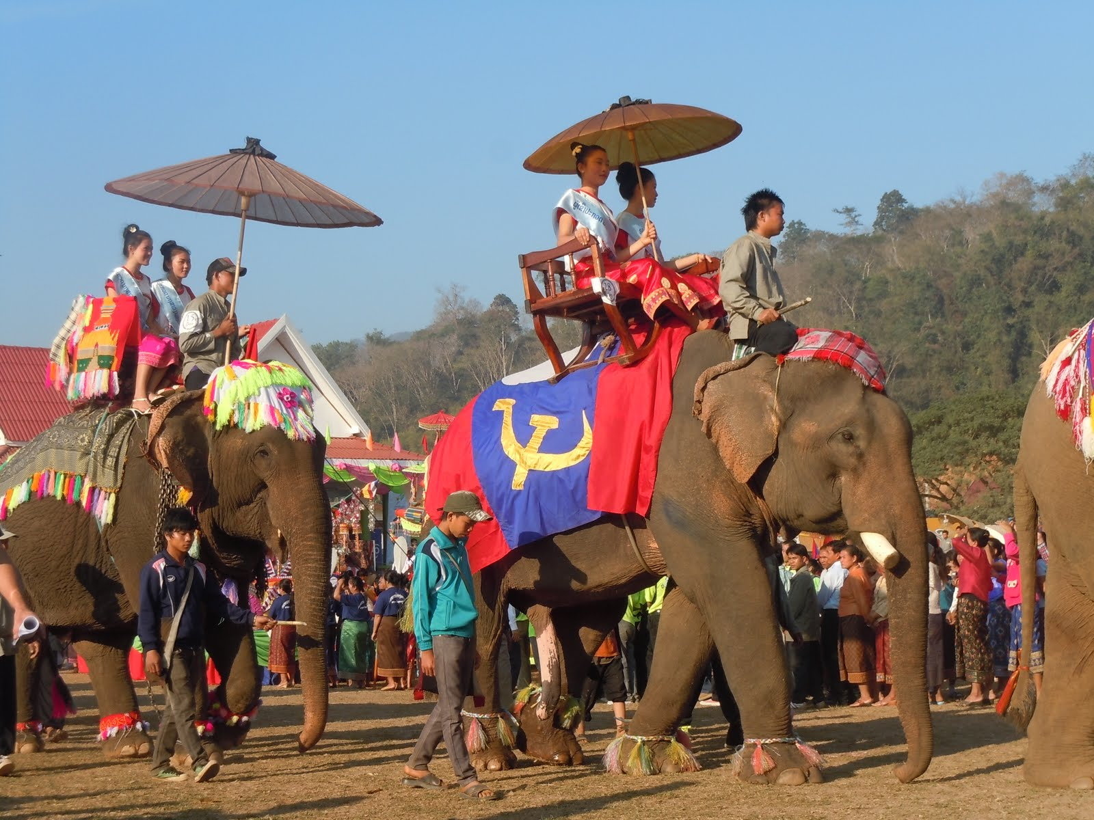

In response to these concerns, the Elephant Festival has been organised to raise awareness of the need for action to protect the Asian elephant as part of the vital cultural and natural heritage of Laos and the countries of the region. Sayaboury Province welcomes you back to pay tribute to its elephants and enjoy great cultural activities and entertainment.

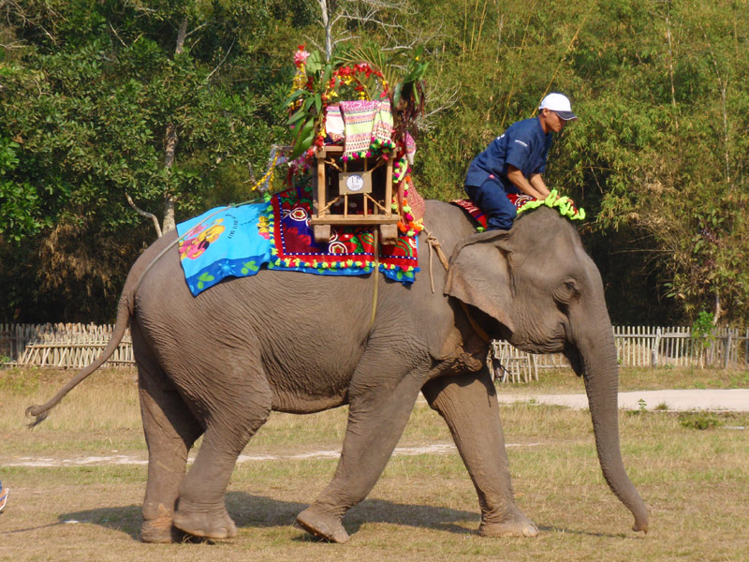

They have been man’s best friend since time immemorial. Traditionally used for work in the forest, these magnificent animals are now looking forward to meeting you at this 6th elephant festival, giving you the chance to discover the riches and marvels of the cultural and natural world surrounding them. Who could pretend to have visited Laos, the “Land of a Million Elephants”, without meeting one of these superb animals? So, come and meet the elephants and their masters at the Elephant Festival...where past and present meet..

*PS: Since 2012, the festival will be hosted in Sayabouri, and will not be managed by Elephant Asia as it was before.*